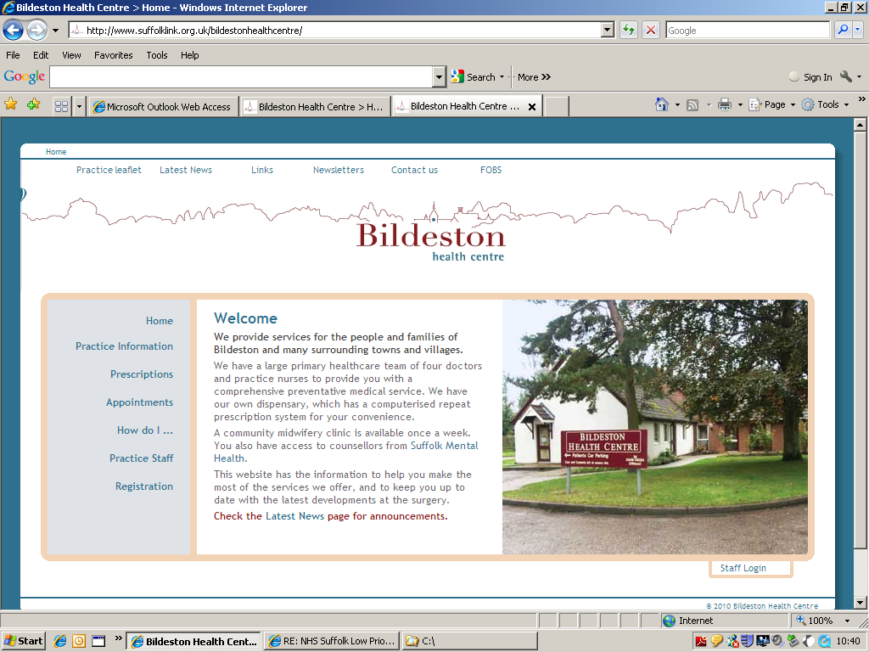
Dr Mark Hainsworth Bildeston Health Centre
Dr David Clark High Street Bildeston
Dr Louise Beale Ipswich IP7 7EX

Tel: 01449 740254

2 April 2022

Minutes / Points from today’s Open PPG Meeting:

As this was an Open Meeting a formal Agenda was not produced.

Sadly, there was a poor turn-out for our ‘Open Meeting’ on 2 April 2022. Whilst the meeting was advertised within the surgery, local shop, on our website, word-of-mouth etc, this did not attract the attendance we had hoped for. The possible reasons for lack of attendance were discussed and we are all thinking hard as to how we can improve on this at our next ‘Open Meeting’.

The main discussion of the meeting was around our Patient Survey. It was suggested that a QR code by included for patients to use via a smartphone/tablet etc, with the results being fed directly back to the surgery. The survey can be put on our website/facebook page/in surgery/posters in village halls and shops/note put on prescription bags. The survey could be completed opportunistically by patients using any of these media options or locations, as well as coming into the surgery – help would be available to those patients unable to complete via the QR code in the form of a paper version.
19.5.22 – Patient survey currently on hold due to internal discussions on ‘how to move forward’.

Next meeting date: To be advised.

