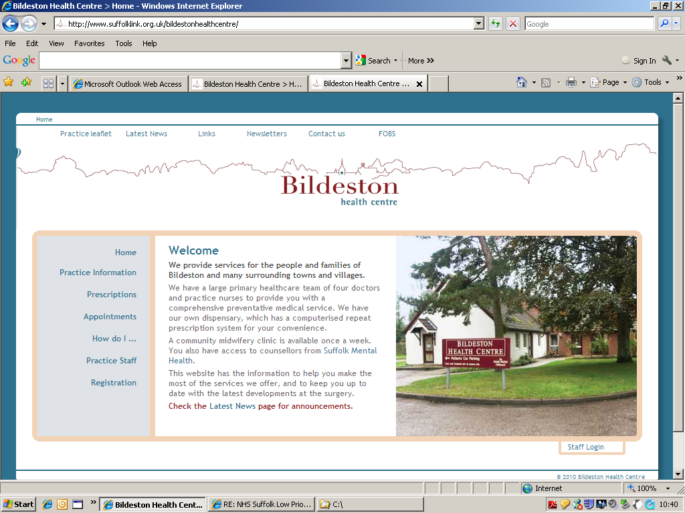
Dr Mark Hainsworth Bildeston Health Centre
Dr Amy Dower High Street Bildeston
Dr Louis Clack Ipswich IP7 7EX

Tel: 01449 740254

Our enthusiastic, friendly, rural Practice is looking to recruit a Qualified Senior Practice Nurse to join our team full-time, although we are happy to consider part-time/job sharing. We do require a degree of flexibility to help with covering holidays as and when needed. Bildeston has approx. 7200 patients.

As a Senior Member of the Practice Nurse Team at Bildeston you will play a crucial role in providing high quality care to our patients. You must be someone who is friendly, patient focussed, calm and well organised, as well as someone who communicates well with people at all levels, provides compassionate care and attention to detail.

We are a SystmOne Practice so experience would be an advantage but full training will be provided to the successful candidate.

In terms of your clinical capabilities, you should be someone who can confidently deal with the following patient needs;

- Monitor Patient Vital Signs and record medical information accurately
- Collaborate with other healthcare professionals to unsure comprehensive patient care.
- Conduct patient assessments and provide appropriate care.
- Cervical Screening/Cytology
- Contraception advice & pill checks
- Baby immunisations
- Administer vaccines and medications as needed.
- Chronic Disease Management (Diabetes and/or Asthma)
- Educate patients on health management and lifestyle choices
- Travel Health
And when needed;

- Assisting with ordering & stock takes
- Phlebotomy
- Dealing with samples
- Wound dressings
- Assist in Minor Surgical Procedures
If you would like to know more about this position please contact Sarah Hutchings our Operations Manager on (01449) 740254 or Sarah.hutchings10@nhs.net

Closing Date: 22/11/24

We do reserve the right to close the advertisement early if we receive a high volume of suitable candidates.

